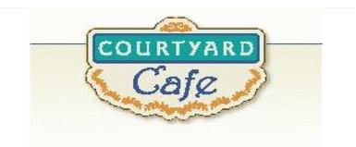  Sandwich Bar  Turkey, ham, Cabot cheddar, Swiss and American  Egg, Chicken, Tuna and Ham salad  Salad Bar/Grab & Go  Available daily with a variety of fresh vegetables, legumes, cheese and other accoutrements sourced locally whenever possible  Local Products  Cheese: Cheddar & Cottage Cabot, Vermont  Eggs: Pete & Gerry’s from Monroe, New Hampshire  Chicken: Sustainably raised chicken breast (antibiotic free, veggie diet, cage free)  Turkey: Sustainably raised turkey breast (antibiotic free, veggie diet, cage free)  Beef: Local grown in Derby, VT, Spring Hill Farms (organic, grass fed)  Please ask a server if you have questions about our products or ingredients. Please let us know if you have food allergies or intolerances. We will be happy to assist you in any way we can.  August 3-7, 2026 | Monday  Meat Lasagna  Made with homemade meat sauce, ricotta, and a blend of seasonings and cheese.  Veggie Lasagna  Stuffed with fresh cut veggies and seasonings for flavor and topped with cheese.  Tuesday  Beef Taco Salad  Local ground beef served on a bed of lettuce with your favorite fixings.  Bean & Cheese Burrito  Refried beans, cheese, and black bean mixture served in a tortilla.  Wednesday  Pulled Pork on Bun served with coleslaw  BBQ shredded pork on a bun or as a side.  Baked Beans & Corn Bread  Vegetarian beans served as a meal or side with cornbread.  Thursday  Parmesan Chicken  A homemade dish with breaded chicken breast, marinara sauce, and mozzarella cheese.  Greek Gnocchi  Potato pasta, broccolini, red onion, feta cheese, all roasted together and tossed in nut free pesto.  Friday  Blackened Salmon  Blackened Salmon cooked to perfection  Lo-Mein  Vegetables, noodles, and homemade sauce.

