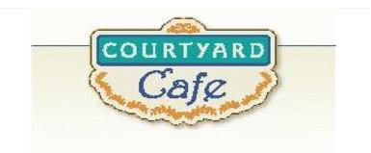  Sandwich Bar  Turkey, ham, Cabot cheddar,  Swiss and American  Egg, Chicken, Tuna and Ham salad  Salad Bar/Grab & Go  Available daily with a variety of fresh vegetables, legumes, cheese and other accoutrements sourced locally whenever possible  Local Products  Cheese: Cheddar & Cottage Cheese from Cabot, Vermont  Eggs: Pete & Gerry’s from Monroe New Hampshire  Chicken: Sustainably raised chicken breast (antibiotic free, veggie diet, cage free)  Turkey: Sustainably raised turkey breast (antibiotic free, veggie diet, cage free)  Beef: Local grown in Vermont (organic, grass fed)  Please ask a server if you have questions about our products or ingredients. Please let us know if you have food allergies or intolerances. We will be happy to get you an ingredient list.  June 8th to June 12th | Monday  Meat Lover’s Pizza  Sausage, pepperoni, and bacon  Mediterranean Vegetable Pizza  Spinach, pepper, red onion, and feta  Tuesday  Beef Shepherd’s Pie  Local beef is used to make this classic  Vegetable Crustless Quiche  Springy and Light  Wednesday  Cheese Tortellini with Sausage  Stuffed pasta in a red meat sauce  Eggplant Parmesan  Nutrient packed eggplant coated with seasoned gluten free panko and topped with mozzarella and a red sauce  Thursday  Chicken Gumbo  Southern comfort food with a splash of Cajun  Lentil Chili  Plant powered protein with lots of flavor  Friday  Fish Cakes  Homemade with haddock, scallions, seasoning and gluten free panko  Chickpea Curry  Homemade curry to spice up  the plant power

