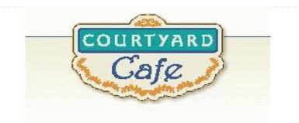  Sandwich Bar  Turkey, ham, Cabot cheddar,  Swiss and American  Egg, Chicken, Tuna and Ham salad  Salad Bar/Grab & Go  Available daily with a variety of fresh vegetables, legumes, cheese and other accoutrements sourced locally whenever possible  Local Products  Cheese: Cheddar & Cottage Cheese from Cabot, Vermont  Eggs: Pete & Gerry’s from Monroe New Hampshire  Chicken: Sustainably raised chicken breast (antibiotic free, veggie diet, cage free)  Turkey: Sustainably raised turkey breast (antibiotic free, veggie diet, cage free)  Beef: Local grown in Vermont (organic, grass fed)  Please ask a server if you have questions about our products or ingredients. Please let us know if you have food allergies or intolerances. We will be happy to assist you in any way we can.  May 25th to May 29th, 2026 | Monday  Grilled Ham and Cheese  Classic comfort with melted cheese and ham  Grilled Cheese  Served on whole wheat-so satisfying  Tuesday  Salisbury Steak  Tender, seasoned beef with mushroom gravy  Roasted Vegetable Tortellini  Cheese-filled pasta tossed with roasted vegetables  Wednesday  Chicken Salad wrap  Chicken salad tossed in a homemade dressing with celery and red grapes  Vegetable Hummus Wrap  Hummus, red onion, peppers, cucumber, tomato and lettuce: plant power  Thursday  Flank Steak w/ Chimi Churi Sauce  Flank steak topped with a southwestern marinade  Black Bean Quesadilla  Warm tortilla filled with black beans and melted cheese  Friday  Breaded Fish Sandwich  Breaded Haddock served on a bun  Greek Gnocchi  Potato pasta, vegetables, and feta all roasted together in a nut free pesto

