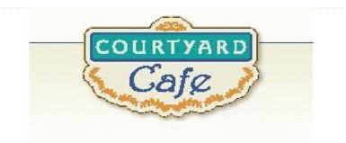  Sandwich Bar  Turkey, ham, Cabot cheddar,  Swiss and American  Egg, Chicken, Tuna and Ham salad  Salad Bar/Grab & Go  Available daily with a variety of fresh vegetables, legumes, cheese and other accoutrements sourced locally whenever possible  Local Products  Cheese: Cheddar & Cottage Cheese from Cabot, Vermont  Eggs: Pete & Gerry’s from Monroe New Hampshire  Chicken: Sustainably raised chicken breast (antibiotic free, veggie diet, cage free)  Turkey: Sustainably raised turkey breast (antibiotic free, veggie diet, cage free)  Beef: Local grown in Vermont (organic, grass fed)  Please ask a server if you have questions about our products or ingredients. Please let us know if you have food allergies or intolerances. We will be happy to assist you in any way we can.  May 11th to May 15th 2026 | Monday  Beef Lasagna  Local beef, marinara, pasta sheets, ricotta mixture  Tofu with Sweet Chili Sauce  Tofu coated and seared in a sweet chili sauce served on rice  Tuesday  Mango Chile Chicken with Strawberry Peach Salsa  Chicken beast marinated in chili powder and mango and served with fruit salsa  Quesadillas  Shredded cheese melted on a tortilla and served with salsa and sour cream  Wednesday  Ribs and Chicken BBQ  Garden Veggie Burgers  Potato Salad and Three Bean Salad  Thursday  Dijion Pork Loin  Pork loin roasted to perfection with Dijon cream sauce, caramelized onion, and apple slices. Served with mashed potatoes  Quiche  Broccoli and Cheese  Friday  Breaded Fish Sandwich  Breaded Pollack served on a bun with coleslaw and French fries  Couscous Salad with Spinach and Sweet Potato  A colorful couscous salad with roasted sweet potato, pomegranate, cor, topped with sunflower seeds and a maple lime dressing

