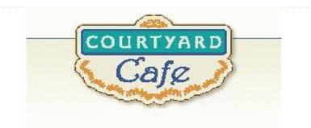  Sandwich Bar  Turkey, ham, Cabot cheddar,  Swiss and American  Egg, Chicken, Tuna and Ham salad  Salad Bar/Grab & Go  Available daily with a variety of fresh vegetables, legumes, cheese and other accoutrements sourced locally whenever possible  Local Products  Cheese: Cheddar & Cottage Cheese from Cabot, Vermont  Eggs: Pete & Gerry’s from Monroe New Hampshire  Chicken: Sustainably raised chicken breast (antibiotic free, veggie diet, cage free)  Turkey: Sustainably raised turkey breast (antibiotic free, veggie diet, cage free)  Beef: Local grown in Vermont (organic, grass fed)  Please ask a server if you have questions about our products or ingredients. Please let us know if you have food allergies or intolerances. We will be happy to assist you in any way we can.  May 4, 2026 to May 8, 2026 | Monday  Spaghetti and Meatballs  Pasta with meatballs…. classic…  Spaghetti Squash Casserole  Comfort food lightened up but still lovable  Tuesday  Chicken Gumbo  Southern comfort food with a splash of Cajun  Vegetarian Stuffed Peppers  Peppers cooked and packed with plant protein  Wednesday  Teriyaki Pork Loin  Sweet and savory and slow-cooked  Vegetable Lo Mein  Noodles and veggies tossed in a savory sauce  Thursday  Sloppy Joes  Have napkins ready…. Delicious  Lentil Sloppy Joes  All of the saucy goodness-no meat required  Friday  Baked Shrimp Tempura  A seafood delight and drizzled with sweet Thai chili sauce  Tuscan Bean Skillet  Warm, savory, and wonderfully rustic and healthy

