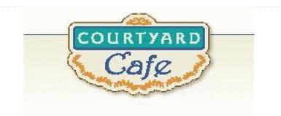  Sandwich Bar  Turkey, ham, Cabot cheddar,  Swiss and American  Egg, Chicken, Tuna and Ham salad  Salad Bar/Grab & Go  Available daily with a variety of fresh vegetables, legumes, cheese and other accoutrements sourced locally whenever possible  Local Products  Cheese: Cheddar & Cottage Cheese from Cabot, Vermont  Eggs: Pete & Gerry’s from Monroe New Hampshire  Chicken: Sustainably raised chicken breast (antibiotic free, veggie diet, cage free)  Turkey: Sustainably raised turkey breast (antibiotic free, veggie diet, cage free)  Beef: Local grown in Vermont (organic, grass fed)  Please ask a server if you have questions about our products or ingredients. Please let us know if you have food allergies or intolerances. We will be happy to assist you in any way we can.  April 20th to April 24th | Monday  Taco Chili Mac  It’s what Taco Tuesday looks like on a Monday!  Spring Vegetable Stew  A garden-fresh medley of veggies in  a smooth, savory herb broth  Tuesday  Pineapple Teriyaki Chicken  Sweet and Savory glazed chicken to  give you that vacation vibe!  Red Curry Tofu  Tofu in a fragrant red curry sauce—  it’s bold, vibrant and satisfying  Wednesday  Roast Turkey  Simple, hearty, and just like home  Macaroni and Cheese  A crowd favorite—we use Cabot  Cheese and Cabot’s recipe  Thursday  Buffalo Chicken Puff Pastry  Flaky, golden pastry packed with  spicy buffalo and ranch  Spanakopita  A Mediterranean pastry filled with  savory spinach, herbs, and cheese  Friday  Fish Casserole  A wholesome dish of fish, a creamy  sauce, and seasoned beautifully  Braised Chickpeas with Spinach  Chickpeas tossed with spinach and  topped with gluten free breadcrumbs.  A plant-powered protein dish.

