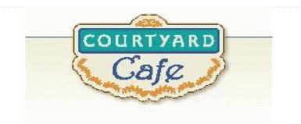  Sandwich Bar  Turkey, ham, Cabot cheddar, Swiss and American  Egg, Chicken, Tuna and Ham salad  Salad Bar/Grab & Go  Available daily with a variety of fresh vegetables, legumes, cheese and other accoutrements sourced locally whenever possible  Local Products  Cheese: Cheddar & Cottage Cabot, Vermont  Eggs: Pete & Gerry’s from Monroe New Hampshire  Chicken: Sustainably raised chicken breast (antibiotic free, veggie diet, cage free)  Turkey: Sustainably raised turkey breast (antibiotic free, veggie diet, cage free)  Beef: Local grown in Vermont (organic, grass fed)  Please ask a server if you have questions about our products or ingredients. Please let us know if you have food allergies or intolerances. We will be happy to assist you in any way we can.  Week of March 2nd to March 6th | Monday  Chicken Gumbo  Guaranteed to warm you up.  Vegetarian Stuffed peppers  Brown rice, black beans, corn, onion, chili peppers, marinara, spices, and diced tomato, topped with cheddar cheese.  Tuesday  Philly Cheese Steak Tortellini  Cheese tortellini, Philly steak, alfredo sauce, onions & peppers.  Mushroom Risotto  Slow cooked Italian rice dish with mushrooms, heavy cream, cheese, and garlic  Wednesday  Lemon Pepper Parmesan Chicken  A fan favorite with a twist  Fall Vegetable Orzo & Chickpeas  Autumn vegetables with chickpeas and orzo.  Thursday  Beef & Broccoli Stir-fry  Beef strips, broccoli, garlic, and ginger, in a GF soy sauce.  Sweet Chili Tofu  Local tofu, Thai chili sauce.  Friday  Blackened Salmon  Fresh Salmon and Cajun seasoning.  Spinach & Artichoke Dip  Spinach, artichokes, blended cheeses, Italian baguette

