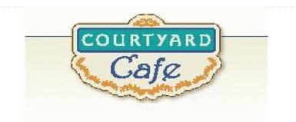  Sandwich Bar  Turkey, ham, Cabot cheddar, Swiss and American  Egg, Chicken, Tuna and Ham salad  Salad Bar/Grab & Go  Available daily with a variety of fresh vegetables, legumes, cheese and other accoutrements sourced locally whenever possible  Local Products  Cheese: Cheddar & Cottage Cabot, Vermont  Eggs: Pete & Gerry’s from Monroe New Hampshire  Chicken: Sustainably raised chicken breast (antibiotic free, veggie diet, cage free)  Turkey: Sustainably raised turkey breast (antibiotic free, veggie diet, cage free)  Beef: Local grown in Vermont (organic, grass fed)  Please ask a server if you have questions about our products or ingredients. Please let us know if you have food allergies or intolerances. We will be happy to assist you in any way we can.  March 16th to March 20th | Monday  Braised Chicken with  Artichokes and Mushroom  Springtime comfort food  Spaghetti Squash Casserole  Tomato, olives, and feta tossed with  baked squash and herbs  Tuesday  Corned beef and cabbage,  potatoes and carrots  Happy St Patrick’s Day!  Cheese Lasagna  Italian comfort food  Wednesday  Teriyaki Pork Loin  Teriyaki marinade  Vegetable Lo Mein  Onion, celery, carrots, mushroom,  peppers, and snow peas  Thursday  Sloppy Joe  Hopefully not too sloppy!  Lentil Sloppy Joes  Lentils and a lot of spices  Friday  Baked Shrimp Tempura  The return of shrimp!  Tuscan Bean Skillet  Tomato, garlic, spinach, and parmesan

