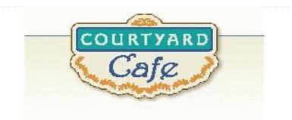  Sandwich Bar  Turkey, ham, Cabot cheddar, Swiss and American  Egg, Chicken, Tuna and Ham salad  Salad Bar/Grab & Go  Available daily with a variety of fresh vegetables, legumes, cheese and other accoutrements sourced locally whenever possible  Local Products  Cheese: Cheddar & Cottage Cabot, Vermont  Eggs: Pete & Gerry’s from Monroe New Hampshire  Chicken: Sustainably raised chicken breast (antibiotic free, veggie diet, cage free)  Turkey: Sustainably raised turkey breast (antibiotic free, veggie diet, cage free)  Beef: Local grown in Vermont (organic, grass fed)  Please ask a server if you have questions about our products or ingredients. Please let us know if you have food allergies or intolerances. We will be happy to assist you in any way we can.  Week of February 9th to 13th | Monday  Crispy Baked Haddock  Baked haddock, with cornflake crumb topping  Spaghetti Squash Casserole  Homemade with tomatoes, olives and feta tossed with baked squash and herbs  Tuesday  Soup Bar  Assorted homemade soups  Grilled Cheese & Ham Sandwich  3 Cheeses melted in between toasted bread with ham  Gluten Free Available  Grilled Cheese Sandwich  3 Cheeses melted in between toasted bread  Gluten Free Available  Wednesday  Roasted Chicken Quarters  Chicken leg and thigh, covered in herbs and roasted.  Roasted Vegetable Polenta Cakes  Corn polenta, topped with roasted vegetables and balsamic glaze.  Thursday  Sloppy Joe  Homemade with local beef, extra sloppy.  Broccoli Casserole  A whole farms worth of broccoli has dedicated themselves to this cheesy dish  Friday  Gluten Free Popcorn Chicken  Dipping sauces on the side.  Mac & Cheese  Everyone’s Homemade Favorite.

