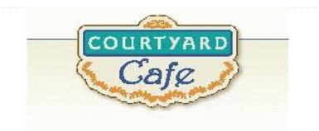  Sandwich Bar  Turkey, ham, Cabot cheddar, Swiss and American  Egg, Chicken, Tuna and Ham salad  Salad Bar/Grab & Go  Available daily with a variety of fresh vegetables, legumes, cheese and other accoutrements sourced locally whenever possible  Local Products  Cheese: Cheddar & Cottage Cabot, Vermont  Eggs: Pete & Gerry’s from Monroe New Hampshire  Chicken: Sustainably raised chicken breast (antibiotic free, veggie diet, cage free)  Turkey: Sustainably raised turkey breast (antibiotic free, veggie diet, cage free)  Beef: Local grown in Vermont (organic, grass fed)  Please ask a server if you have questions about our products or ingredients. Please let us know if you have food allergies or intolerances. We will be happy to assist you in any way we can.  February 2nd to February 6th  2026 | Monday  Meat Lovers Pizza  Pepperoni, bacon, and sausage.  Gluten Free Available  Mediterranean Vegetable Pizza  Spinach, roasted red peppers, red onion, feta cheese.  Gluten Free Available  Tuesday  Beef Shepherd’s Pie  Homemade with local beef, mashed potato, and corn.  Vegetable Crustless Quiche  Homemade with egg, heavy cream, onions, peppers, tomato, zucchini, garlic, cheddar.  Wednesday  Cheese Tortellini with Sausage  Cheese stuffed tortellini with sausage and red sauce.  Eggplant Parmesan  A homemade dish with eggplant covered in seasoned gluten free panko crumbs, marinara sauce, and mozzarella cheese.  Thursday  BBQ Pork Ribs  Pork ribs with homemade bbq sauce.  Lentil Chili  Lentils, vegetables, and a touch of spice  Friday  Fish Cakes  Homemade with haddock, scallion, peppers, mayo, and GF Panko  Chickpea Curry  Homemade with curry powder, coconut milk, veggies lime and chickpeas

