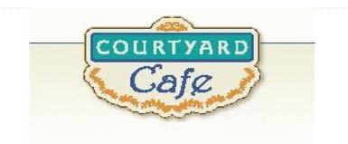  Sandwich Bar  Turkey, ham, Cabot cheddar, Swiss and American  Egg, Chicken, Tuna and Ham salad  Salad Bar/Grab & Go  Available daily with a variety of fresh vegetables, legumes, cheese and other accoutrements sourced locally whenever possible  Local Products  Cheese: Cheddar & Cottage Cabot, Vermont  Eggs: Pete & Gerry’s from Monroe New Hampshire  Chicken: Sustainably raised chicken breast (antibiotic free, veggie diet, cage free)  Turkey: Sustainably raised turkey breast (antibiotic free, veggie diet, cage free)  Beef: Local grown in Vermont (organic, grass fed)  Please ask a server if you have questions about our products or ingredients. Please let us know if you have food allergies or intolerances. We will be happy to assist you in any way we can.  Week of December 22nd to December 26th | Monday  Chicken Gumbo  Guaranteed to warm you up.  Vegetarian Stuffed peppers  Brown rice, black beans, corn, onion, chili peppers, marinara, spices, and diced tomato, topped with cheddar cheese.  Tuesday  Beef & Broccoli Stir-fry  Beef strips, broccoli, garlic, and ginger in a gluten free soy sauce.  Sweet Chili Tofu  Local tofu, tossed in a Thai sweet chili sauce  Wednesday  Lemon Pepper Parmesan Chicken  A fan favorite with a twist  Fall Vegetable Orzo & Chickpeas  Autumn vegetables with chickpeas and orzo.  Christmas Day  Beef Strip Loin  Sweet Potato Lasagna  Mashed Potato  Roasted Vegetable Medley  Friday  Gluten Free Popcorn Chicken  Dipping sauces on the side  Spinach & Artichoke Dip  Spinach, artichokes, blended cheeses, Italian baguette

