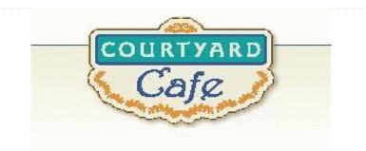  Sandwich Bar  Turkey, ham, Cabot cheddar, Swiss and American  Egg, Chicken, Tuna and Ham salad  Salad Bar/Grab & Go  Available daily with a variety of fresh vegetables, legumes, cheese and other accoutrements sourced locally whenever possible  Local Products  Cheese: Cheddar & Cottage Cabot, Vermont  Eggs: Pete & Gerry’s from Monroe New Hampshire  Chicken: Sustainably raised chicken breast (antibiotic free, veggie diet, cage free)  Turkey: Sustainably raised turkey breast (antibiotic free, veggie diet, cage free)  Beef: Local grown in Vermont (organic, grass fed)  Please ask a server if you have questions about our products or ingredients. Please let us know if you have food allergies or intolerances. We will be happy to assist you in any way we can.  Week of December 1st to 5th | Monday  Sloppy Joe  Homemade with local beef, extra sloppy.  Butternut Squash & Pumpkin Ravioli  Butternut squash & pumpkin ravioli in a sage cream sauce.  Tuesday  Soup Bar  Assorted homemade soups  Grilled Cheese & Ham Sandwich  3 Cheeses melted in between toasted bread with ham  Gluten Free Available  Grilled Cheese Sandwich  3 Cheeses melted in between toasted bread  Gluten Free Available  Wednesday  Roasted Chicken Quarters  Chicken leg and thigh, covered in herbs and roasted.  Lentil Chili  Homemade chili with lentils, onion, kidney beans, black beans, green chilies, tomato sauce, and plenty of spices.  Thursday  BBQ Pulled Pork  Pork with a homemade bbq sauce.  Mac & Cheese  Everyone’s Homemade Favorite.  Friday  Crispy Baked Haddock  Baked haddock, with cornflake crumb topping  Spaghetti Squash Casserole  Homemade with tomatoes, olives and feta tossed with baked squash and herbs

