FOR IMMEDIATE RELEASE

NVRH hosts exhibit of photographs by Patricia Shine

ST. JOHNSBURY, VT (November 20, 2025) – The Hanna and Charles Gray Gallery at Northeastern Vermont Regional Hospital (NVRH) is pleased to announce the opening of a new exhibit by Concord photographer Patricia Shine.

Patricia’s vibrant yet peaceful images reflect quiet glimpses of the extraordinary beauty that surrounds us every day.
“I am grateful to have moved from Boston to the Northeast Kingdom more than twenty years ago,” she says. “The beauty of this community continues to inspire me—every dirt road tells its own story and the wonders within our backyards never disappoint. Through my photography, I hope to offer a moment of respite from the pressures and challenges of daily life and to remind us all of the splendor found right here in our own special corner of the world.”
The exhibit will be on display at The Charles M. and Hannah H. Gray Gallery located on the hospital’s main floor through January 5, 2026. 25% of all sales from the exhibit will directly benefit NVRH and its mission to provide exceptional care to our community.
To learn more about the gallery and the current exhibit, visit the Charles M. and Hanna H. Gray Gallery webpage at nvrh.org or contact the gallery Curator Jennifer Layn at j.layn@nvrh.org or 802-748-7313.

Northeastern Vermont Regional Hospital is located in St. Johnsbury in the Northeast Kingdom of Vermont. We are a community, not-for-profit, acute care, critical access hospital. NVRH is one of two Vermont hospitals designated as Baby FriendlyTM by the United Nations. The organization provides primary and preventive care, surgical and specialty services, inpatient and outpatient care and 24-hour, physician-staffed emergency services. Aligned with community partners, NVRH values and invests in efforts to address social conditions to create communities that are well-nourished, well-housed, physically and mentally healthy, and financially secure. NVRH serves the health needs for over 30,000 people in Caledonia and southern Essex Counties in Vermont and employs over 700 dedicated staff.

###

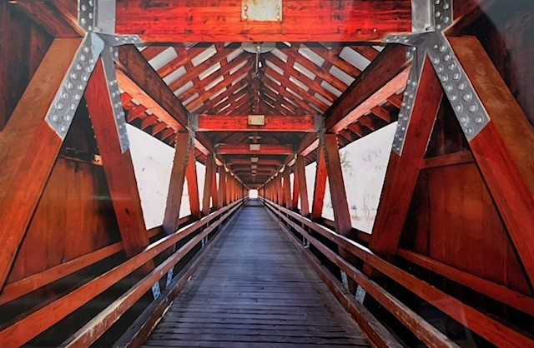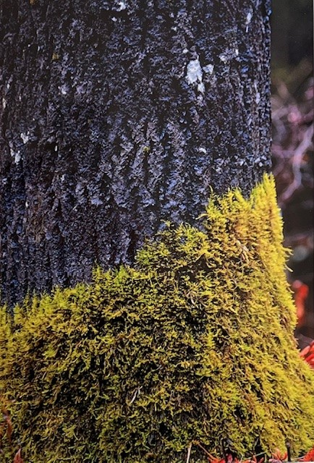

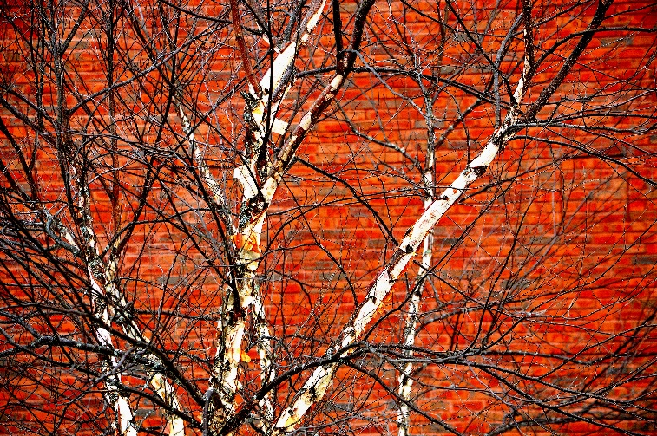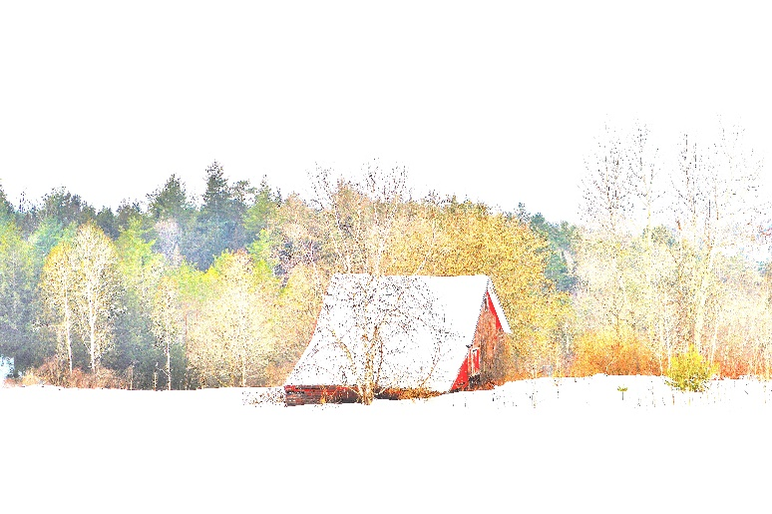

Photo Caption: Patricia Shine’s photographs will be on display at the Charles M. and Hanna H. Gray gallery at NVRH through January 5, 2026.

