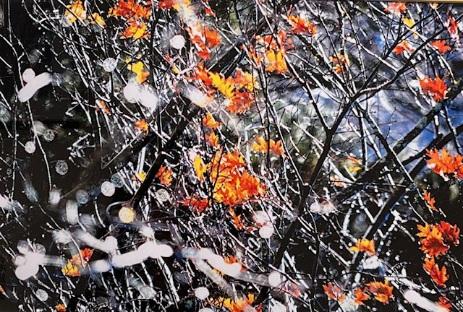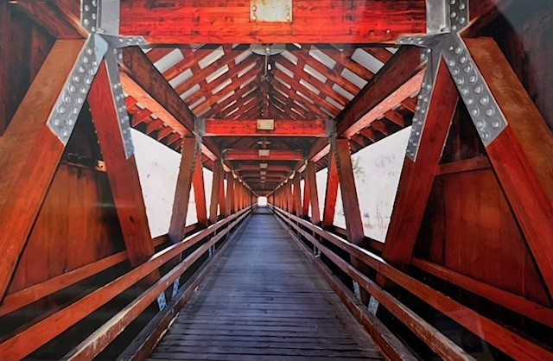
The Hanna and Charles Gray Gallery at Northeastern Vermont Regional Hospital (NVRH) is pleased to announce the opening of a new exhibit by Concord photographer Patricia Shine.
Patricia’s vibrant yet peaceful images reflect quiet glimpses of the extraordinary beauty that surrounds us every day.
“I am grateful to have moved from Boston to the Northeast Kingdom more than twenty years ago,” she says. “The beauty of this community continues to inspire me—every dirt road tells its own story and the wonders within our backyards never disappoint. Through my photography, I hope to offer a moment of respite from the pressures and challenges of daily life and to remind us all of the splendor found right here in our own special corner of the world.”
The exhibit will be on display at The Charles M. and Hannah H. Gray Gallery located on the hospital’s main floor through January 5, 2026. 25% of all sales from the exhibit will directly benefit NVRH and its mission to provide exceptional care to our community.
To learn more about the gallery and the current exhibit, visit the Charles M. and Hanna H. Gray Gallery webpage at nvrh.org or contact the gallery Curator Jennifer Layn at j.layn@nvrh.org or 802-748-7313.

