FOR IMMEDIATE RELEASE

A singular vision
Artist and retired RN Dawn Griffis creates evocative artwork despite vision loss

ST. JOHNSBURY, VT (October 11, 2025) – “Did you know that an English blackbird has over a hundred different songs?”

Artist Dawn Griffis has a deep love for and understanding of the natural world. Her evocative pastels portray the delicate bluebells, peonies, and cowslips that she recalls from her childhood and the birds that she’s observed both in England and Vermont–rose-breasted grosbeaks, robins, and blackbirds.

A retired RN and nurse practitioner, Dawn continues to create art despite a tremor and progressive vision loss from macular degeneration, drawing on her vivid memory and the assistance of sighted people to create her artwork. Her pastels are currently on display at the Charles M. and Hanna H. Gray Gallery at NVRH (Northeastern Vermont Regional Hospital).

“I love birds. I love flowers,” she says, pointing out that the English blackbirds and robins differ greatly from their American counterparts. It’s the smaller, plumper English robin that appears in her artwork, drawn from the vivid memories of her youth rather than what she observes from her home in rural Vermont.

Dawn met her husband, Mike, when she was in nursing school, and moved with him to the US in 1965, their life together unfolding across the U.S. as they navigated the demands of his military career and raised two daughters. They lived in nine different states before settling in Vermont in 1977.

She worked in different media before settling on pastels, which give her work a soft, dreamy quality but also capture the bright eye of the robin and a squirrel’s vivacious tail. “I tried many other things but they weren’t quite right for me—the pastels were much more forgiving. It works for me.”

Dawn’s artwork will be on display at the Gray Gallery located on the hospital’s main floor through November 25. 25% of all sales from the exhibits will directly benefit NVRH. See a preview of her work or click here for a price list. To learn more about the gallery, contact the gallery Curator Jennifer Layn at j.layn@nvrh.org or 802-748-7313

Northeastern Vermont Regional Hospital is located in St. Johnsbury in the Northeast Kingdom of Vermont. We are a community, not-for-profit, acute care, critical access hospital. NVRH is one of two Vermont hospitals designated as Baby FriendlyTM by the United Nations. The organization provides primary and preventive care, surgical and specialty services, inpatient and outpatient care and 24-hour, physician-staffed emergency services. Aligned with community partners, NVRH values and invests in efforts to address social conditions to create communities that are well-nourished, well-housed, physically healthy, mentally healthy, and financially secure. NVRH serves the health needs for over 30,000 people in Caledonia and southern Essex Counties in Vermont and employs over 700 dedicated staff.

##
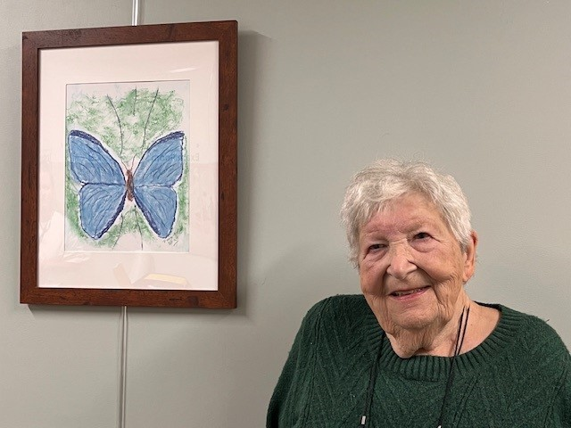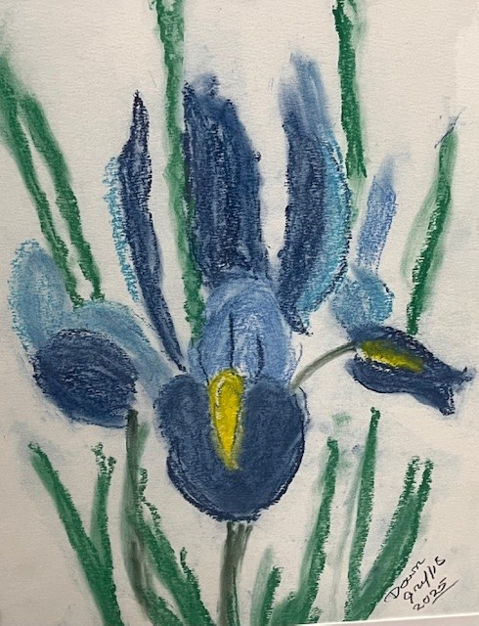

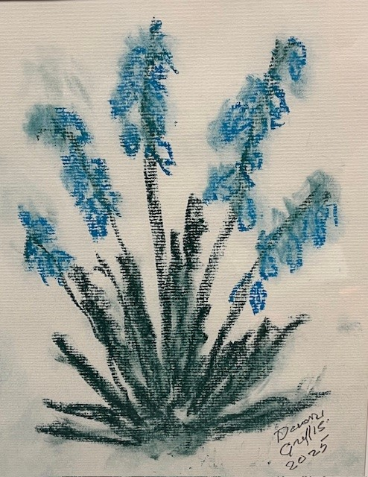
Artist and retired RN and NP Dawn Griffis continues to make evocative art despite vision loss from macular degeneration.

